**Neha Malhotra**  **R.L. Institute M: 9416974837**

**Subject: Biology**

**Topic: Cell : Structure and Functions**

**M.M. 280 COMPETITIVE TEST**  **Time: 60 Min.**

1. Who proposed the theory that ‘Cells arise only from the pre-existing cells’?

|  |  |  |  |
| --- | --- | --- | --- |
| a) Mohl | b) Virchow | c) Haeckel | d) Brown |

1. Which one of the following is not an inclusion body found in prokaryotes?

|  |  |  |  |
| --- | --- | --- | --- |
| a) Cyanophycean granules | b) Glycogen granules | c) Polysomes | d) Phosphate granules |

1. Which structures perform the function of mitochondria in bacteria?

|  |  |  |  |
| --- | --- | --- | --- |
| a) Nucleoid | b) Ribosomes | c) Cell wall | d) Mesosomes |

1. Phospholipid are important cell membrane constituents because :

|  |  |
| --- | --- |
| a) contain glycerol | b) can form bilayers in water |
| c) Combine covalently with protein | d) Contain polar and non-polar portions |

1. Unsaturated fatty acids have :

|  |  |  |  |
| --- | --- | --- | --- |
| a) Palmitic acid | b) Oleic acid | c) 1 or more double bond | d) both (b) and (c) |

1. Middle lamella is composed mainly of:

|  |  |  |  |
| --- | --- | --- | --- |
| a) Muramic acid | b) calcium pectate | c) phosphoglycerides | d) hemicellulose |

1. Lysosomes have a high content of

|  |  |  |  |
| --- | --- | --- | --- |
| a) Hydrolytic enzymes | b) Lipoproteins | c) Polyribosomes | d) DNA ligase |

1. Ingestion of solid food by plasma membrane is called :

|  |  |  |  |
| --- | --- | --- | --- |
| a) Endosmosis | b) Pinocytosis | c) Cytokinesis | d) Phagocytosis |

1. Which of the following substances are stored in Aleuroplasts?

|  |  |  |  |
| --- | --- | --- | --- |
| a) Starch | b) oil and lipids | c) proteins | d) Water and oils |

1. The bright colour of ripe fruits are due to :

|  |  |  |  |
| --- | --- | --- | --- |
| a) Leucoplasts | b) chloroplast | c) Amyloplasts | d) Chromoplasts |

1. Which of the following will yield only glucose on hydrolysis?

|  |  |  |  |
| --- | --- | --- | --- |
| a) Sucrose | b) lactose | c) Maltose | d) Raffinose |

1. The most abundant organic compound in biosphere is :

|  |  |  |  |
| --- | --- | --- | --- |
| a) lignin | b) Cellulose | c) Pectin | d) Hemicellulose |

1. Starch is made up of :

|  |  |  |  |
| --- | --- | --- | --- |
| a) Fructose | b) Cellobiose | c) Amylopectin | d) Amino acids |

1. An example of hexose sugar is :

|  |  |  |  |
| --- | --- | --- | --- |
| a) Mannose | b) Galactose | c) Arabinose | d) Both (a) and (b) |

1. Identify the meiotic stage in which the homologous chromosomes separate while the sister chromatids remain associated at their centromeres :

|  |  |  |  |
| --- | --- | --- | --- |
| a) Metaphase I | b) Metaphase II | c) Anaphase I | d) Anaphase II |

1. Ribosomal RNA is actively synthesized in :

|  |  |  |  |
| --- | --- | --- | --- |
| a) lysosomes | b) Nucleolus | c) Nucleoplasm | d) Ribosomes |

1. The principle protein of cilia and flagella is :

|  |  |  |  |
| --- | --- | --- | --- |
| a) Tubulin | b) Nexin | c) Myosin | d) albumin |

1. Number of protofilament in microtubule is :

|  |  |  |  |
| --- | --- | --- | --- |
| a) 10 | b) 12 | c) 5 | d) 13 |

1. Hereditary characters are due to :

|  |  |  |  |
| --- | --- | --- | --- |
| a) Chromosomes | b) gene | c) Blood | d) Placenta |

1. The non-protein organic factor firmly attached to apoenzyme is called :

|  |  |  |  |
| --- | --- | --- | --- |
| a) metal ion | b) co-enzyme | c) Prosthetic group | d) activator |

1. Histone protein synthesis in :

|  |  |  |  |
| --- | --- | --- | --- |
| a) G1 phase | b) G2 phase | c) S phase | d) prophase |

1. During cell cycle DNA replicates :

|  |  |  |  |
| --- | --- | --- | --- |
| a) One | b) twice | c) many times | d) not all |

1. The duration of cell cycle in yeast is :

|  |  |  |  |
| --- | --- | --- | --- |
| a) 90 minutes | b) 90 seconds | c) 24 hours | d) 24 minutes |

1. A cell organelle that contains hydrolytic enzymes are :

|  |  |  |  |
| --- | --- | --- | --- |
| a) Microsomes | b) ribosomes | c) lysosomes | d) Mesosomes |

1. Which one of the following biomolecules is correctly characterized?
2. Lecithin – A phosphorylated glyceride found in cell membrane.
3. Palmitic acid – An unsaturated fatty acid with 18 carbon atoms.
4. Adenylic acid – Adenosine with a glucose phosphate molecule.
5. Alanine amino acid – Contains an amino group and an acidic group anywhere in the molecule.
6. Cell wall is absent in :

|  |  |  |  |
| --- | --- | --- | --- |
| a) Nostoc | b) aspergillus | c) Funaria | d) Mycoplasma |

1. A non-proteinaceous enzyme is :

|  |  |  |  |
| --- | --- | --- | --- |
| a) Lysozyme | b) Ribozyme | c) Ligase | d) Deoxyribonuclease |

1. Match column I and column II

|  |  |  |
| --- | --- | --- |
| Column I | Column II | |
| A. Thylakoids | I. Disc-shaped sacs in Golgi apparatus | |
| B. Cristae | II. Condensed structure of DNA | | |
| C. Cisternae | III. Flat membranous sacs in stroma | |
| D. Chromatin | IV. Infoldings in mitochondria | |
| a) A – III ; B – IV ; C – I ; D – II | | | b) A – III ; B – I ; C – IV ; D – II | | |
| c) A – III ; B – IV ; C – II ; D – I | | | d) A – IV ; B – III ; C – I ; D – II | | |

1. Which one of the following structures between two adjacent cells is an effective transport pathway?

|  |  |  |  |
| --- | --- | --- | --- |
| a) Plasmodesmata | b) Plastoquinone | c) ER | d) Plasmalemma |

1. Which one of the following has its own DNA?

|  |  |  |  |
| --- | --- | --- | --- |
| a) Mitochondria | b) Dictyosomes | c) Lysosome | d) peroxisomes |

1. The main arena of various types of activities of a cell is :

|  |  |  |  |
| --- | --- | --- | --- |
| a) plasma membrane | b) mitochondria | c) cytoplasm | d) nucleus |

1. The two sub-units of ribosome remain united a critical ion level of :

|  |  |  |  |
| --- | --- | --- | --- |
| a) Copper | b) manganese | c) Magnesium | d) calcium |

1. What is common between chloroplasts, Chromoplasts and leucoplasts?

|  |  |
| --- | --- |
| a) presence of pigments | b) Possession of thylakoids and grana |
| c) storage of starch, proteins and lipids | d) Ability to multiply by a fission like process |

1. The ribosomes are made up of :

|  |  |  |  |
| --- | --- | --- | --- |
| a) DNA + Protein | b) RNA + Protein | c) DNA + RNA | d) none of these |

1. The 80S ribosomes are found in :

|  |  |  |  |
| --- | --- | --- | --- |
| a) Eukaryotic cells | b) Prokaryotic cells | c) Bacterial cells | d) Cyanobacterial cells |

1. Chromosome with centromere at one end is :

|  |  |  |  |
| --- | --- | --- | --- |
| a) Metacentric | b) Sub-metacentric | c) Telocentric | d) Acrocentric |

1. The function of nucleolus is the synthesis of:

|  |  |  |  |
| --- | --- | --- | --- |
| a) DNA | b) mRNA | c) rRNA | d) tRNA |

1. During gamete formation, the enzymes recombinase participates during :

|  |  |  |  |
| --- | --- | --- | --- |
| a) Prophase I | b) Prophase II | c) Metaphase I | d) Anaphase II |

1. Terminalization is related to :

|  |  |  |  |
| --- | --- | --- | --- |
| a) Diakinesis | b) diplotene | c) zygotene | d) pachytene |

1. Crossing over occur during :

|  |  |  |  |
| --- | --- | --- | --- |
| a) Pachytene | b) diplotene | c) diakinesis | d) zygotene |

1. The complex formed by a pair of synapsed homologous chromosome is called :

|  |  |  |  |
| --- | --- | --- | --- |
| a) Kinetochore | b) divalent | c) axoneme | d) equatorial plates |

1. Spindle fibres attach on to :

|  |  |
| --- | --- |
| a) Kinetosome of the chromosome | b) Telomere of the chromosome |
| c) Kinetochore of the chromosome | d) Centromere of the chromosome |

1. Which of the following is not a characteristics of feature during mitosis in somatic cells ?

|  |  |
| --- | --- |
| a) Synapsis | b) Spindle fibres |
| c) Disappearance of nucleolus | d) Chromosome movement |

1. The sequence of cell cycle is :

|  |  |  |  |
| --- | --- | --- | --- |
| a) S , M , G1 and G2 | b) G1 , G2 , S and M | c) M , G1 , G2 and S | d) G1 , S , G2 and M |

1. Inulin is a :

|  |  |  |  |
| --- | --- | --- | --- |
| a) lipid | b) Protein | c) polysaccharide | d) Human insulin |

1. The most abundant structural polysaccharide is cellulose. And the second largest structural polysaccharide is :

|  |  |  |  |
| --- | --- | --- | --- |
| a) Chitin | b) Mannan | c) Glycogen | d) Gyaluronic acid |

1. Phospholipids are __________ in nature.

|  |  |  |  |
| --- | --- | --- | --- |
| a) Hydrophilic | b) Amphibolic | c) Hydrophobic | d) Amphipathic |

1. Monomer of chitin is :

|  |  |  |  |
| --- | --- | --- | --- |
| a) N-acetyl glucosamine | b) Mannitol | c) Glucuronic acid | d) Ascorbic acid |

1. Cellulose is :

|  |  |
| --- | --- |
| a) Heptopolysaccharide | b) Heteropolysaccharide , branched |
| c) Hexose polysaccharide, unbranched | d) Pentosan polysaccharide , branched |

1. Cilia and flagella both have :

|  |  |
| --- | --- |
| a) 9 + 2 arrangement of microtubule | b) protective structure of cells |
| c) Only present in protozoa animals | d) Only outgrowth structure of cytoplasm |

1. Centrioles and centrosomes are present in cells of :

|  |  |  |  |
| --- | --- | --- | --- |
| a) Bacteria | b) cyanobacteria | c) green plants | d) animals |

1. Nuclear DNA exists as a complex of proteins called ______ that condenses into ______ during cellular division.

|  |  |
| --- | --- |
| a) chromosomes , chromatin | b) chromatid , chromosome |
| c) chromatids, chromatin | d) chromatin , chromosomes |

1. The organelle devoid of DNA but capable of duplication is :

|  |  |  |  |
| --- | --- | --- | --- |
| a) Plastids | b) nucleus | c) Centriole | d) Mitochondria |

1. Which of the following cytoplasmic strands are present in pit through which the cytoplasm of one cell is in contact with other?

|  |  |  |  |
| --- | --- | --- | --- |
| a) bordered pit | b) simple pit | c) Plasmodesmata | d) intussusception |

1. Which of the following structures is present in mitochondria?

|  |  |  |  |
| --- | --- | --- | --- |
| a) Quantosome | b) Centrosome | c) Dictyosomes | d) Oxysomes |

1. The acidic condition with in the lysosome is maintained by :

|  |  |
| --- | --- |
| a) Digestive enzymes synthesized on RER | b) Pumping Cl – ion out of lysosomes |
| c) Pumping protons (H+) into the lysosomes | d) All of the above |

1. Which of the face of Golgi associated with ER?

|  |  |
| --- | --- |
| a) Forming face ; Trans face | b) Maturing face ; Trans face |
| c) Both forming and maturing face | d) Forming face ; Cis face |

1. The below structure formula belongs to :

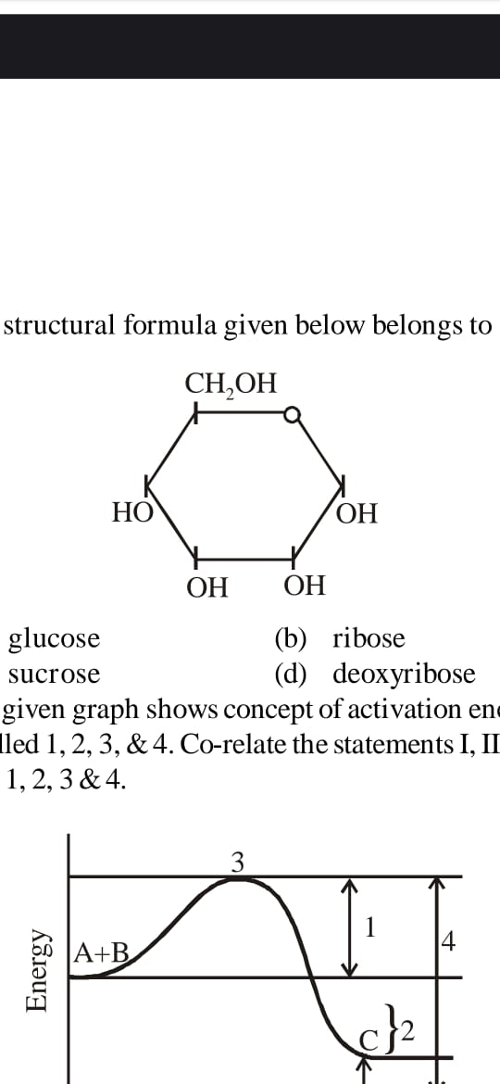

|  |  |  |  |
| --- | --- | --- | --- |
| a) Glucose | b) Ribose | c) Sucrose | d) Deoxyribose |

1. Which of the two groups of following formula involved in peptide bond between different amino acids?

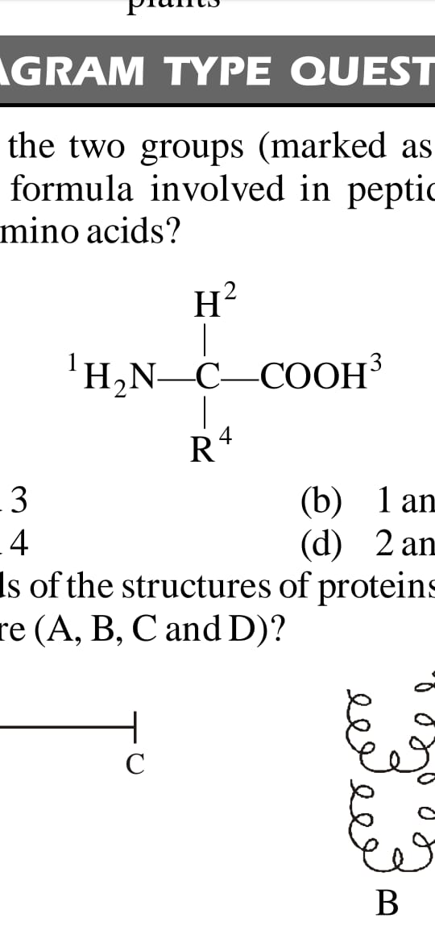

|  |  |  |  |
| --- | --- | --- | --- |
| a) 2 & 3 | b) 1 & 3 | c) 1 & 4 | d) 2 & 4 |

1. A major site for lipid synthesis is :

|  |  |  |  |
| --- | --- | --- | --- |
| a) SER | b) symplast | c) Nucleoplasm | d) RER |

1. The motile bacteria are able to move by :

|  |  |  |  |
| --- | --- | --- | --- |
| a) Fimbriae | b) flagella | c) cilia | d) pilli |

1. The solid linear cytoskeletal elements having a diameter of 6 nm and made up of a single type of monomer is known as :

|  |  |  |  |
| --- | --- | --- | --- |
| a) microtubules | b) microfilaments | c) intermediate filament | d) lamins |

1. The portion of chromosome above secondary constriction is called :

|  |  |  |  |
| --- | --- | --- | --- |
| a) Telomere | b) centromere | c) satellite | d) chromatid |

1. In mammalian RBCs, plasma membrane has ratio of protein and lipid are :

|  |  |  |  |
| --- | --- | --- | --- |
| a) 50 % and 50 % | b) 60 % and 40 % | c) 40 % and 52 % | d) 52 % and 40 % |

1. The membrane covered vacuole is called :

|  |  |  |  |
| --- | --- | --- | --- |
| a) Desmosomes | b) tonoplast | c) plasmodesmata | d) tyloses |

1. Which of the following structures shows polymorphism :

|  |  |  |  |
| --- | --- | --- | --- |
| a) Golgi apparatus | b) lysosomes | c) mitochondria | d) chloroplast |

1. The organelle participates in packaging of material discovered by ?

|  |  |  |  |
| --- | --- | --- | --- |
| a) Robert brown | b) Flemming | c) Camillo Golgi | d) George Palade |

1. Most simple amino acid is :

|  |  |  |  |
| --- | --- | --- | --- |
| a) Tyrosine | b) Lysine | c) Glycine | d) Aspartic acid |

1. Which of the following is basic amino acid?

|  |  |  |  |
| --- | --- | --- | --- |
| a) Leucine | b) Lysine | c) methionine | d) Aspartic acid |

1. The primary structure of protein is made up of :

|  |  |  |  |
| --- | --- | --- | --- |
| a) Hydrogen bond | b) Ionic bond | c) Peptide bond | d) None of these |

**[Class =11th]**

**Answers**

|  |
| --- |
| 1. B |
| 1. C |
| 1. D |
| 1. D |
| 1. D |
| 1. B |
| 1. A |
| 1. D |
| 1. C |
| 1. D |
| 1. C |
| 1. B |
| 1. C |
| 1. D |
| 1. C |
| 1. B |
| 1. A |
| 1. D |
| 1. A |
| 1. C |
| 1. C |
| 1. B |
| 1. A |
| 1. C |
| 1. A |
| 1. D |
| 1. B |
| 1. A |
| 1. A |
| 1. A |

**Topic: Cell : Structure & Functions**

|  |
| --- |
| 1. C |
| 1. C |
| 1. D |
| 1. B |
| 1. A |
| 1. C |
| 1. C |
| 1. A |
| 1. B |
| 1. A |
| 1. B |
| 1. C |
| 1. A |
| 1. D |
| 1. C |
| 1. A |
| 1. D |
| 1. A |
| 1. C |
| 1. A |
| 1. D |
| 1. D |
| 1. C |
| 1. C |
| 1. D |
| 1. C |
| 1. D |
| 1. A |
| 1. B |
| 1. A |

|  |
| --- |
| 1. B |
| 1. B |
| 1. C |
| 1. D |
| 1. B |
| 1. B |
| 1. C |
| 1. C |
| 1. B |
| 1. C |
|  |
|  |
|  |
|  |
|  |
|  |
|  |
|  |
|  |
|  |
|  |
|  |
|  |
|  |
|  |
|  |
|  |
|  |
|  |
|  |